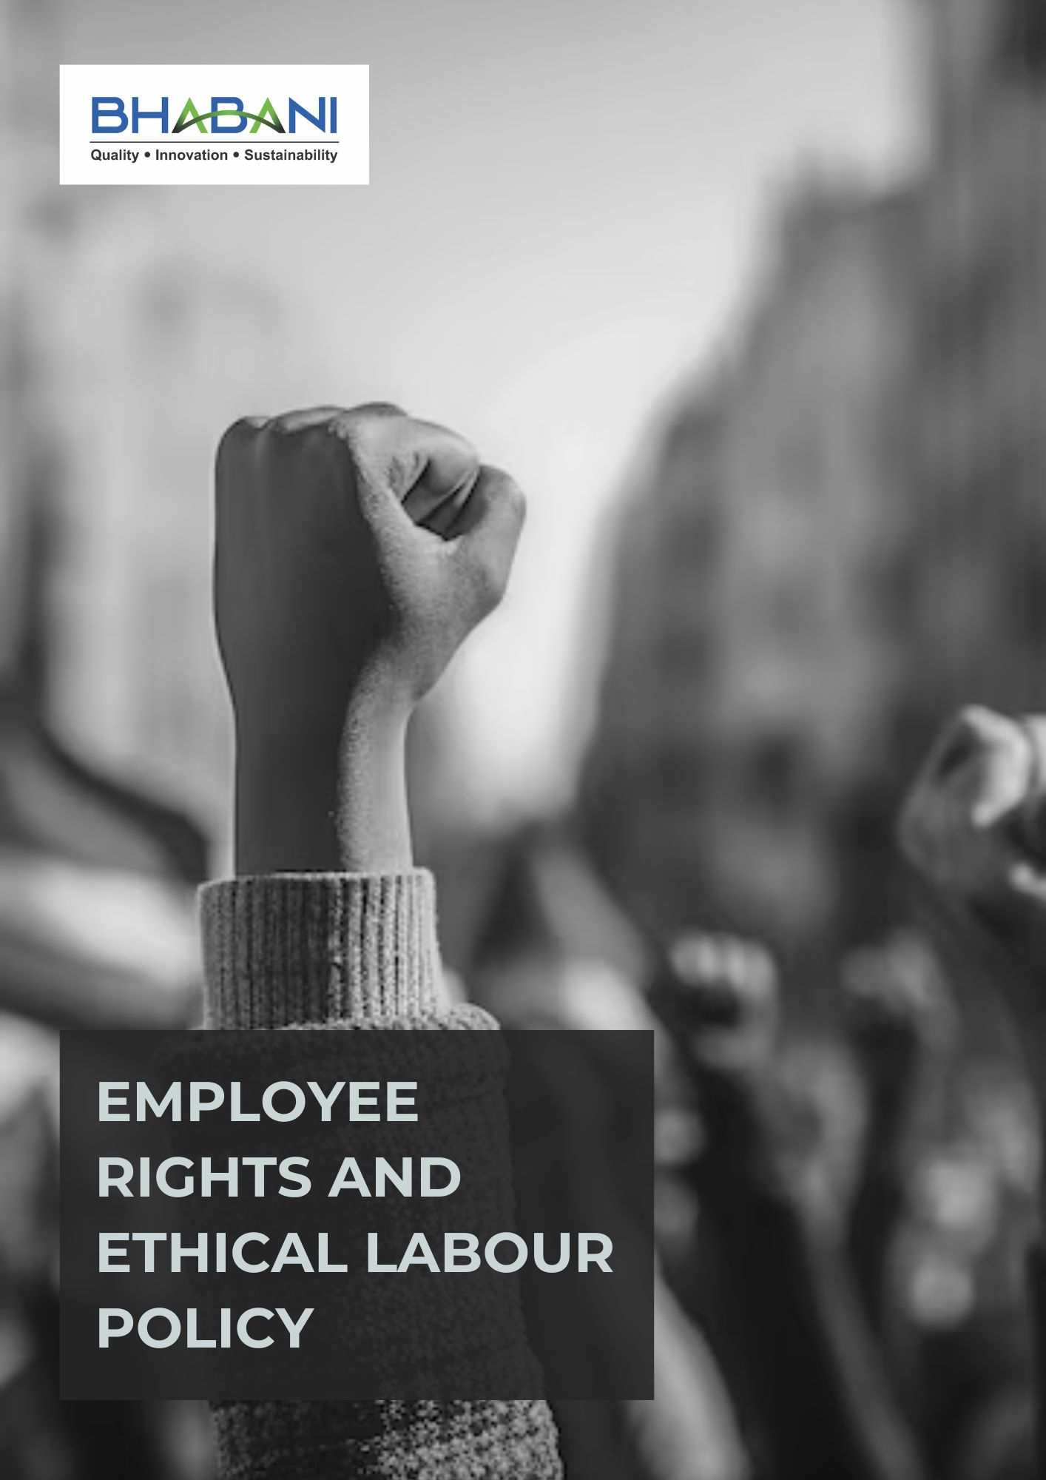

TABLE OF CONTENTS
PREFACE 2
POLICY DECLARATION 2
SCOPE 2
KEY FOCUS AREAS 3
QUALITATIVE OBJECTIVES 3
QUANTITATIVE TARGETS 5
ALIGNMENT WITH THE UNITED NATIONS SUSTAINABLE DEVELOPMENT GOALS (SDGS) 7
RESPONSIBILITIES 7
MONITORING, REPORTING, AND TRANSPARENCY 8
REVIEW MECHANISM 8
EMPLOYEE ACKNOWLEDGMENT FORM 9

PREFACE

Bhabani Colors Pvt. Ltd. is committed to creating and maintaining a workplace that respects and promotes human rights and fair labor practices. The Company prioritizes safe, healthy, and supportive working conditions for all employees, ensuring that ethical standards are embedded across all operations.

The Company is dedicated to providing equal opportunities for all employees, promoting diversity and inclusion, and ensuring fair and consistent treatment irrespective of background or status. This commitment is reinforced through continuous engagement, structured training, and open communication mechanisms, ensuring that human rights principles are actively integrated into organizational culture and long-term business practices.

POLICY DECLARATION

The Company affirms its responsibility to operate with integrity and social accountability by embedding ethical labor practices and human rights principles into all business activities. It is committed to maintaining safe and dignified working environments, ensuring fairness in employment practices, preventing all forms of exploitation and abuse, and promoting an inclusive and respectful organizational culture. This policy establishes a clear framework for responsible conduct, accountability, and continuous strengthening of labor and human rights standards across the organization and its stakeholder relationships.

SCOPE

This policy applies to all employees, contractors, suppliers, business partners, and service providers of Bhabani Colors Pvt. Ltd. It covers employment practices, working conditions, occupational health and safety, employee development, and workforce well-being. All covered parties are required to comply with applicable labor laws and human rights standards in line with the Company’s commitment to ethical and responsible business conduct.:

Sr. No. | Site | Address
1 | Bhabani Colors Pvt. Ltd. | A-30/BI, Mohan Cooperative Industrial Estate, New Delhi - 110044
1 | Bhabani Colors Pvt. Ltd. | SP7, MIA, Alwar - 301030, Rajasthan

KEY FOCUS AREAS
- Employee Health & Safety – Maintain safe and healthy workplace by strengthening safety systems, risk prevention, and employee well-being.
- Working Conditions – Provide safe, respectful, and supportive working environments that protect employee well-being.
- Social Dialogue – Promote open and transparent communication between management and employees through formal channels & regular feedback.
- Career Development & Training – Support employee growth through annual performance reviews, skill development programs, and internal promotion opportunities.
- Child Labor, Forced Labor & Human Trafficking – Enforce zero-tolerance policies and uphold ethical labor standards across company operations and supply chains.
- Non-Discrimination & Harassment – Promote equal opportunity, diversity, and an inclusive workplace free from discrimination or harassment.
- External Stakeholder Human Rights – Respect and promote human rights among suppliers and business partners through due diligence, contract clauses, and regular reviews.
- Fair Wages & Benefits – Ensure wages and benefits remain fair, competitive, and compliant with legal and industry standards.
- Work-Life Balance – Encourage healthy work practices that help employees balance professional and personal well-being.

QUALITATIVE OBJECTIVES
- Employee Health and Safety
- To enhance safety protocols regularly to address workplace risks, prevent accidents and provide readily accessible health and safety resources and information to all staff.
- Promote safe work practices and proactive risk identification.

- Working Conditions
- Ensure all workplaces meet statutory requirements related to cleanliness, ventilation, lighting, and welfare facilities.
- Promote respectful supervision and ethical management practices at all levels of the organization.

- Social Dialogue
- To maintain an open and transparent communication culture between management and employees, ensuring regular feedback mechanisms and proactive resolution of workplace concerns.

- Career Development & Training
- To conduct annual performance reviews to support career advancement and encourage internal mobility by promoting from within when possible.
- Align training programs with technological advancements, and regulatory requirements.

- Child Labor, Forced Labor, & Human Trafficking
- Maintain zero-tolerance policies on child and forced labor throughout operations.
- Conduct background checks on suppliers to ensure compliance with labor standards.
- Protect fundamental human rights in all business activities.

- Non-Discrimination & Harassment
- Promote equal opportunity and an inclusive workplace free from discrimination or harassment.
- Strengthen and continuously improve grievance redressal mechanisms to ensure fair, timely, and transparent resolution of concerns.

- External Stakeholder Human Rights
- Respect human rights across suppliers, partners, and communities.
- Encourage ethical practices throughout the supply chain.
- Maintain open communication and grievance mechanisms to address stakeholder concerns transparently and build trust.

- Fair Wages & Benefits
- Ensure wages and benefits are fair, competitive, and legally compliant.
- Periodically review compensation structures to support employee welfare.

- Work-Life Balance
- Promote supportive policies that help employees balance professional and personal responsibilities.
- Ensure workloads are properly managed to maintain productivity and employee well-being.

QUANTITATIVE TARGETS
All objectives defined in this Policy use 2024 as the baseline for measurement. Progress will be reviewed annually, with the aim of reaching defined milestones by year 2030. This includes advancing employee well-being, ensuring ethical labor practices, promoting diversity and inclusion, maintaining fair wages and benefits, and fostering responsible engagement with partners and stakeholders.

- Employee Health and Safety
- Increase workplace safety inspections by 25% by 2030 to proactively identify risks.
- Reduce absenteeism due to work-related injuries by 50% by 2030.

- Working Conditions
- Achieve a 95% positive response rate in annual employee satisfaction surveys by 2030.
- Provide statutory healthcare and insurance benefits to 100% eligible employees by year 2030.

- Social Dialogue
- Achieve 90% attendance in labor-management meetings by year 2030.
- Achieve 100% participation in employee feedback activities by year 2030.

- Career Development and Training
- Conduct annual performance reviews and maintain documented development plans for 100% eligible employees.
- Increase internal promotions by 25% by 2030.
- Allocate 5% of annual budget to employee development and career programs by 2030.

- Child Labor, Forced Labor, and Human Trafficking
- Ensure 100% supplier compliance with child and forced labor policies by 2030.
- Include human rights clauses in 100% of new supplier contracts by 2030.
- Maintain 0 confirmed cases of child labor, forced labor, or human trafficking across Bhabani operations annually.

- Non-Discrimination & Harassment
- Conduct 2 workplace climate surveys on discrimination and harassment till year 2030 through survey forms filled by 100% employees.
- Maintain zero confirmed cases of discrimination or harassment.
- Provide mandatory anti-harassment, POSH and DEI training to 100% employees annually.

- External Stakeholder Human Rights
- Ensure that 100% of supplier contracts include and comply with human rights clauses by year 2030.
- Train 100% of procurement and supply-chain personnel annually on human rights policies.

- Fair wages & Benefits
- Provide statutory and company-sponsored benefits (including insurance, social security, and retirement benefits) to 100% eligible employees.
- Ensure 100% compliance with all applicable minimum wage, wage payment, and statutory benefit requirements across locations, with zero instances of wage-related non-compliance.

- Work-Life Balance
- Ensure 100% compliance with statutory working hours, overtime limits, and leave entitlements.
- Offer flexible work arrangements for 100% eligible employees, subject to role feasibility.

ALIGNMENT WITH THE UNITED NATIONS SUSTAINABLE DEVELOPMENT GOALS (SDGS)
The sustainability objectives and performance targets align with the following Sustainable Development Goals (SDGs):
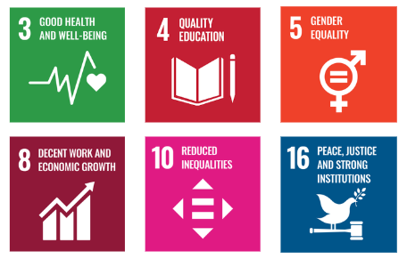

RESPONSIBILITIES
The Human Resources (HR) Manager will be responsible for compiling and preparing the annual labor and human rights performance report. This will be done in coordination with:
- HR Manager: Oversees policy implementation, employee training, and compliance with labor standards.
- Operations Manager: Ensures safe working conditions, monitors employee health and safety, and implements career development programs.
- DEI Committee: Drives diversity, equity, and inclusion initiatives and monitors progress.
- Compliance Officer: Audits suppliers and enforces policies on child and forced labor prevention.
- Senior Management: Reviews progress, allocates resources, and provides strategic direction for human rights and labor practices.

MONITORING, REPORTING, AND TRANSPARENCY
Bhabani Colors Pvt. Ltd. undertakes continuous monitoring of its labor standards and human rights performance across key areas such as employee health and safety, working conditions, social dialogue, learning and career development, prevention of child and forced labor, non-discrimination and harassment, and the protection of external stakeholder human rights. The Company tracks defined Key Performance Indicators (KPIs) through established internal monitoring mechanisms, with quarterly reviews and consolidated reporting to senior management to support informed decision-making. Annual evaluations assess overall progress, identify improvement areas, and drive corrective actions, while appropriate disclosures are made to stakeholders to enhance transparency and accountability. All monitoring and reporting processes are aligned with applicable labor regulations, international human rights principles, and industry best practices to ensure accuracy, reliability, and credibility.

REVIEW MECHANISM

The HR Manager, will conduct annual review of this policy to assess policy effectiveness, monitor compliance, and adjust targets as needed. The review process includes analyzing quarterly reports, gathering employee feedback, and benchmarking against industry standards. Findings are reported to CEO, and policy adjustments are made to ensure continuous improvement in labor and human rights practices at Bhabani Colors Pvt. Ltd.

REV. No. 02

LAST REVIEW DATE: 01.01.2026 NEXT REVIEW DATE: 01.01.2027
APPROVED BY:

EMPLOYEE ACKNOWLEDGMENT FORM
I hereby acknowledge that I have read and understood the Employee Rights and ethical labour Policy of Bhabani Colors Pvt. Ltd. and am aware of the Company’s commitment to fair, ethical, and responsible labor practices. This includes the prevention of child labor and forced labor, the prohibition of discrimination and harassment, and the promotion of safe and healthy working conditions. I recognize that respect for human rights is a shared responsibility and commit to upholding these principles in my day-to-day conduct by treating colleagues, contractors, and all stakeholders with dignity, fairness, and respect.
By signing this document, I affirm my commitment to the labor and human rights values of Bhabani Colors Pvt. Ltd. and agree to actively support the Company’s efforts to maintain a safe, inclusive, and equitable workplace, including participation in required training programs, awareness initiatives, and continuous improvement activities.

Employee Name | : _________________________
Employee ID | : _________________________
Department | : _________________________
Signature | : _________________________

